REVIEW 3 – GROUP II – 23- APR – 2019

1. **SITE MAP**
2. **Client’s site map**

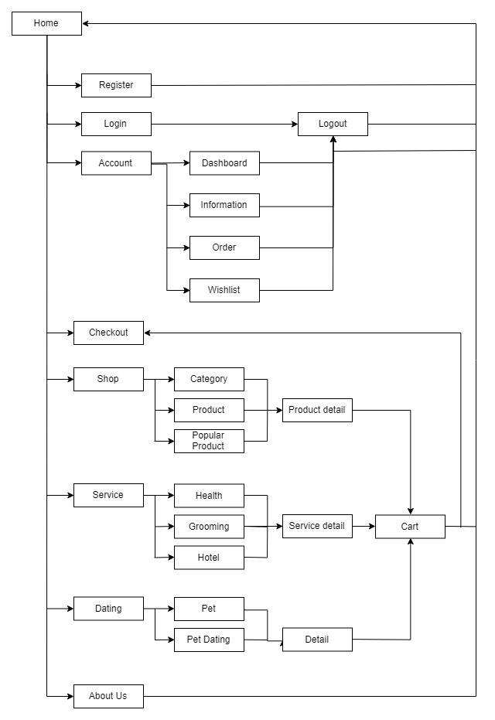

1. **Admin’s site map**
2. **GUI DESIGN**
3. **Client’s side**
   * 1. ***Home***

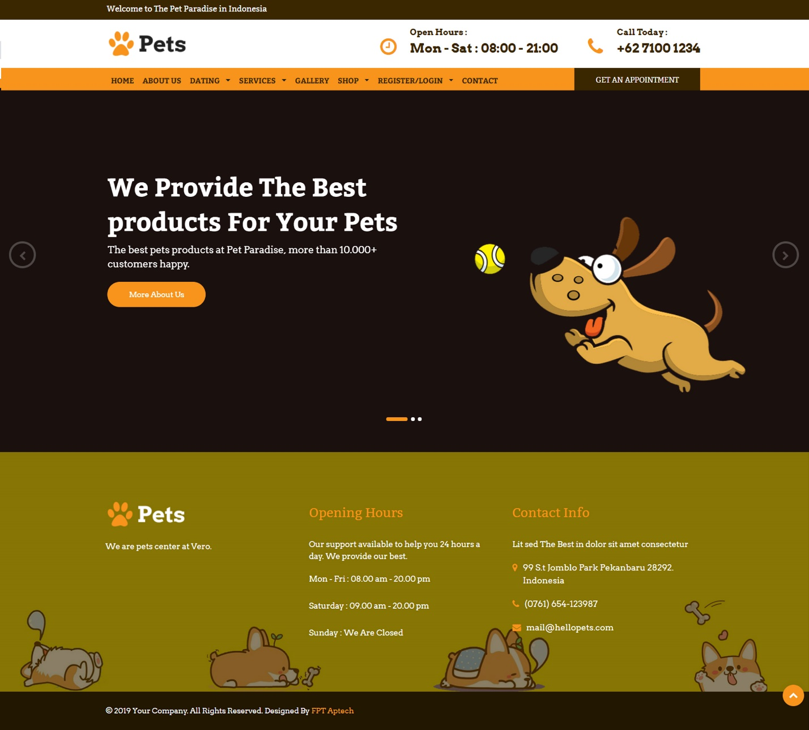

|  |  |
| --- | --- |
| Description | Home page |
| Connect From | N/A |
| Connect To | Login page, Sign Up, Product page, Shop, Services, Gallery.. |
| Validation | N/A |
| Initial Values | N/A |
| Events | - Navigate the website by clicking on menu Shop, Service, .. |

* + 1. ***Register***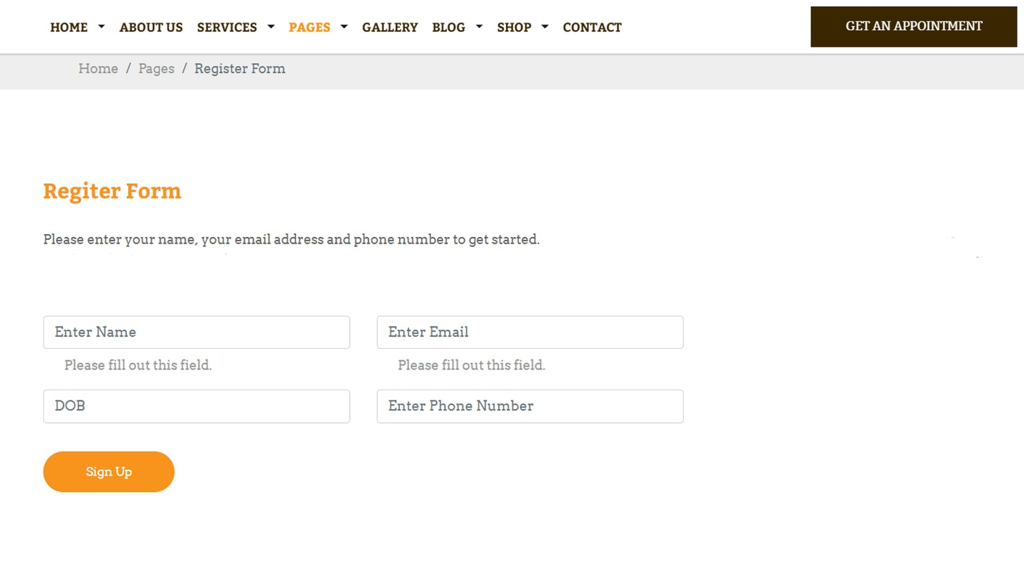

|  |  |
| --- | --- |
| Description | Guest signs up for new account |
| Connect From | Home |
| Connect To | Login page, Home |
| Validation | - All fields: not blank  - Name: must be not contains special characters  - Email: must be valid email format  - Password: must be between 6 to 20 characters - Phone Number: must be unique, valid phone number |
| Initial Values | N/A |
| Events | - When click button "Sign Up", check phone and password. If success, go to login page |

* + 1. ***Login***

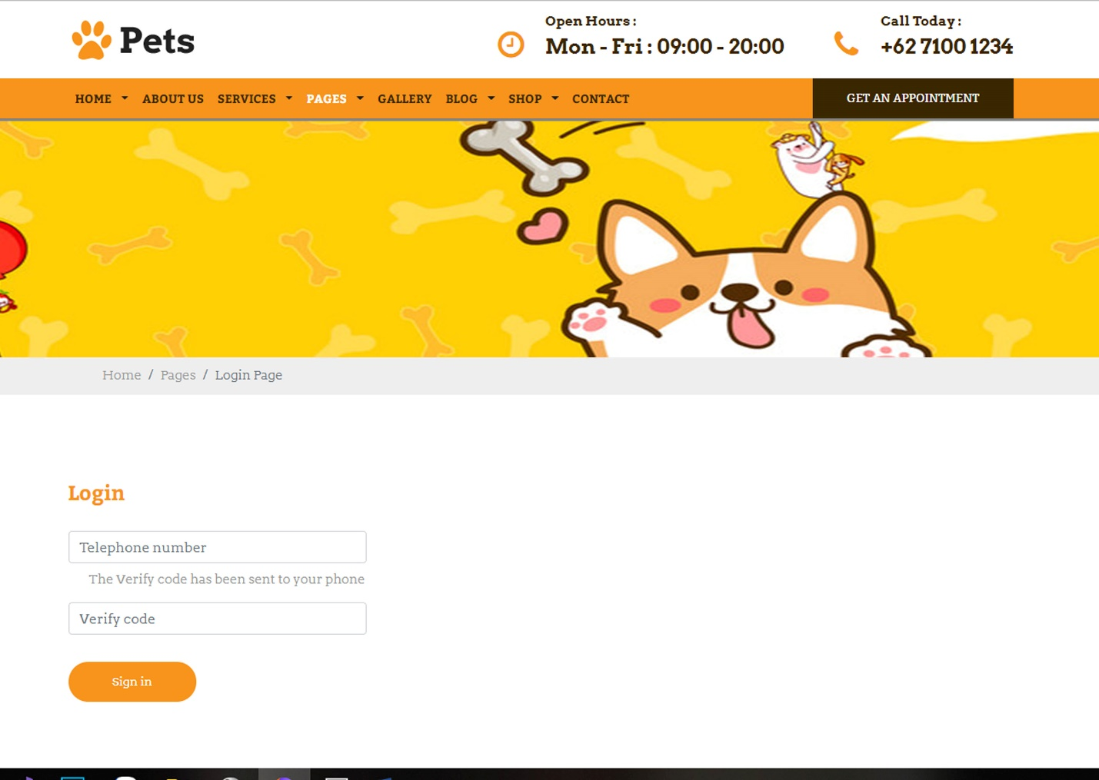

|  |  |
| --- | --- |
| Description | Login with Phone Number and Verify code |
| Connect From | Home |
| Connect To | Customer’s profile |
| Validation | All fields: not blank - Phone: must be valid phone number format - Verify: from SMS |
| Initial Values | N/A |
| Events | - When click button "Sign In", check phone number, then login. Login success, go to profile page |

* + 1. ***Dating list***

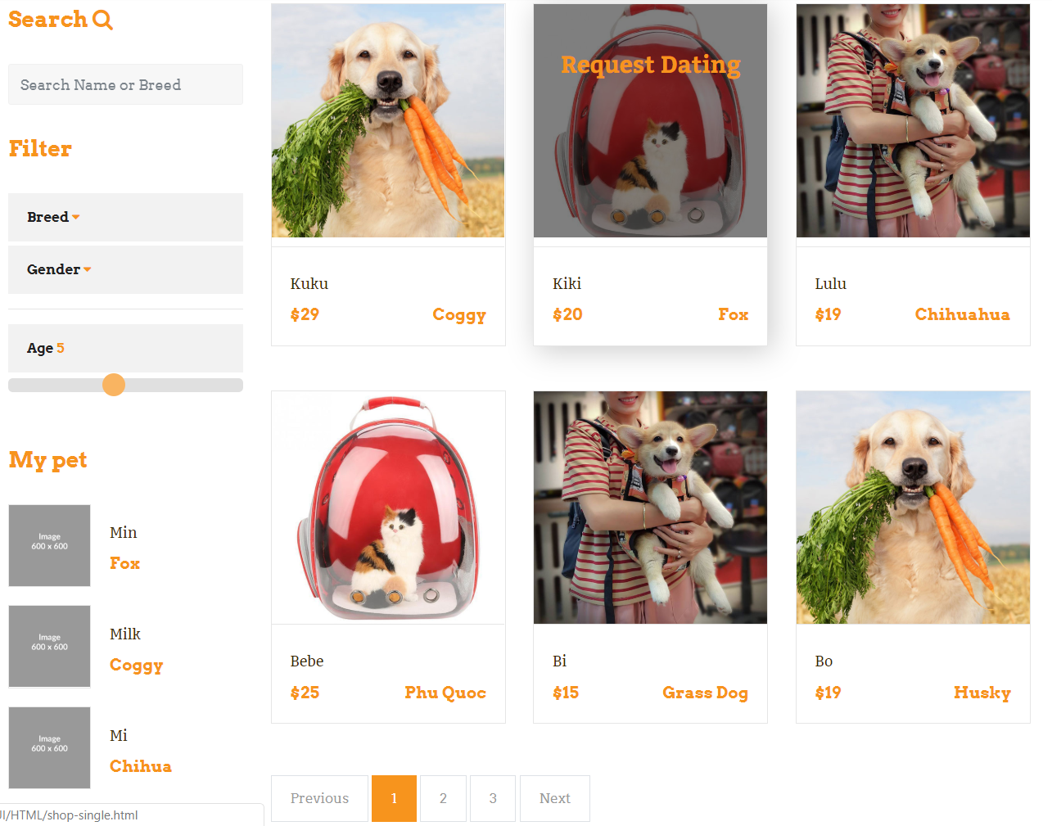

* + 1. ***Pet Dating***

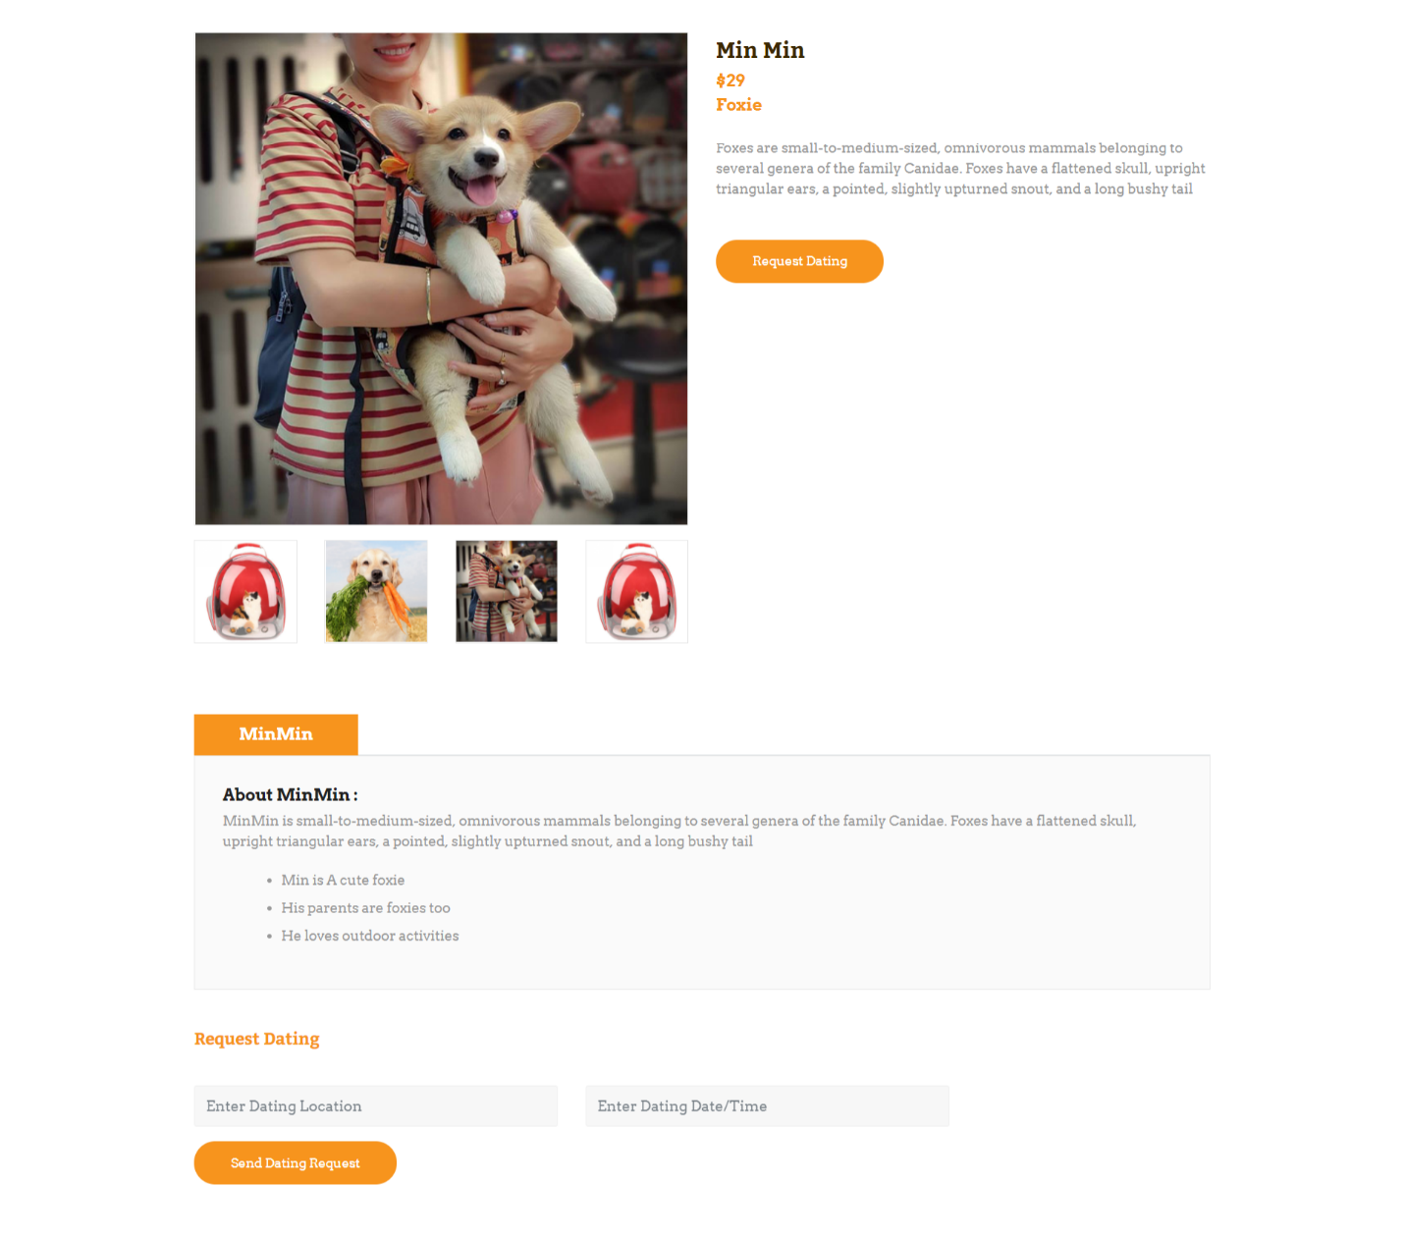

* + 1. ***Pet list***

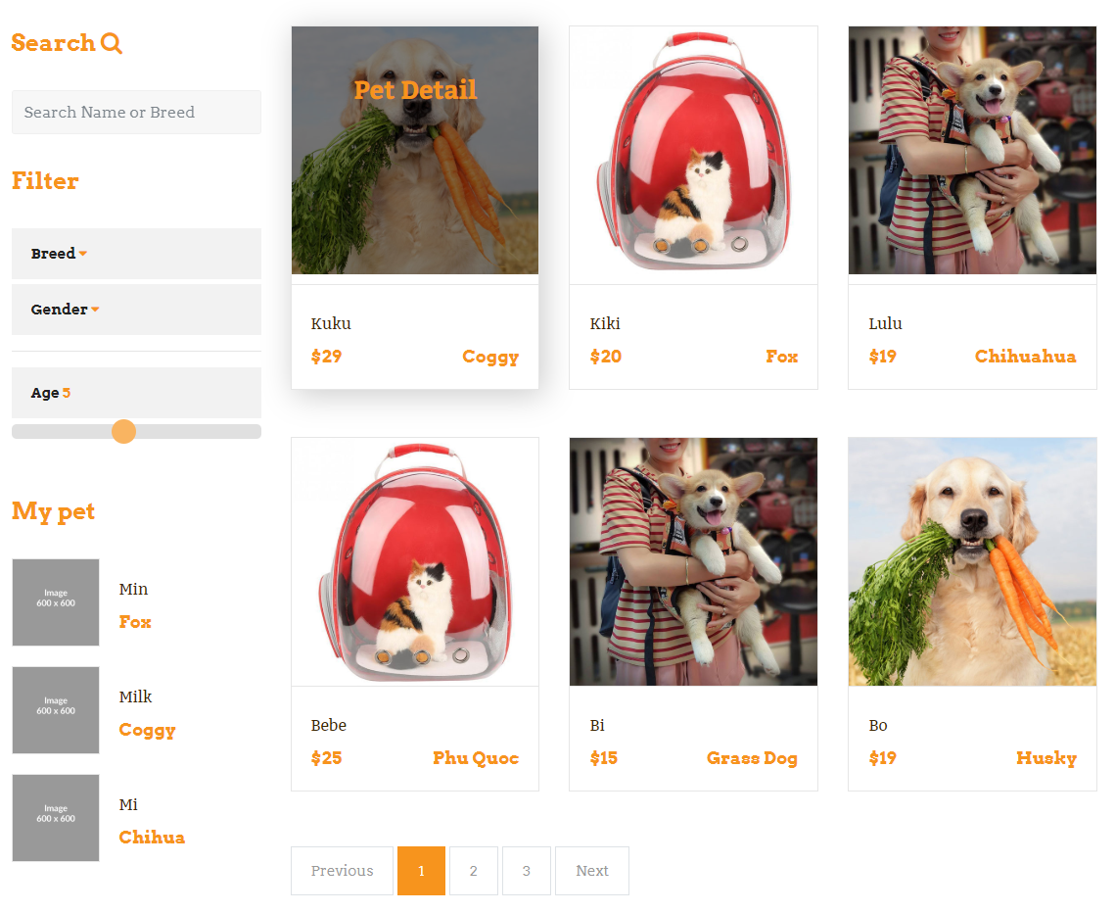

* + 1. ***Pet detail***

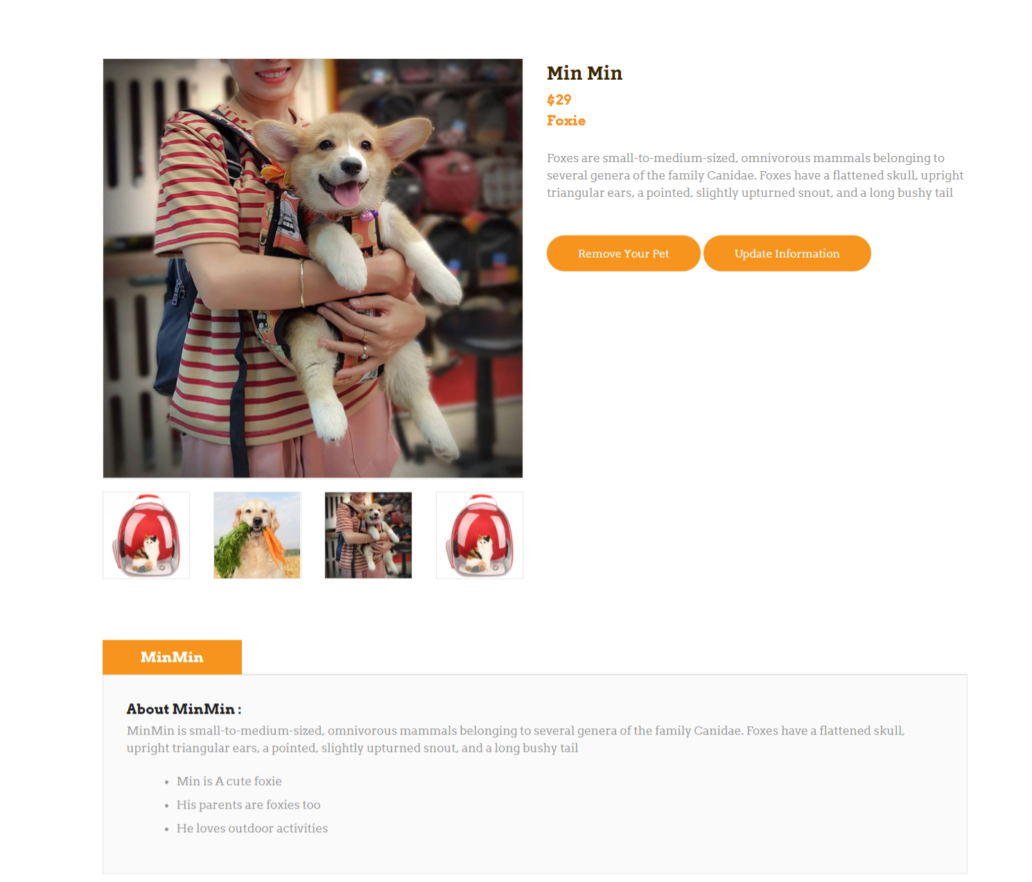

* + 1. ***Pet Add***

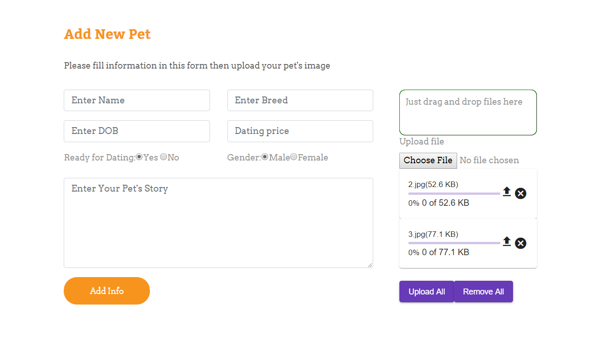

* + 1. ***Pet Update***

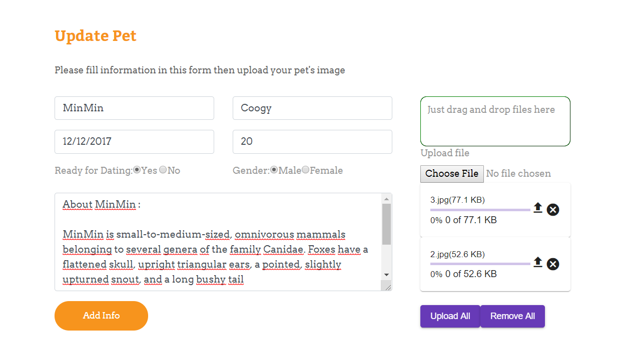

* + 1. ***Update customer’s profile***
    2. ***Gallery***

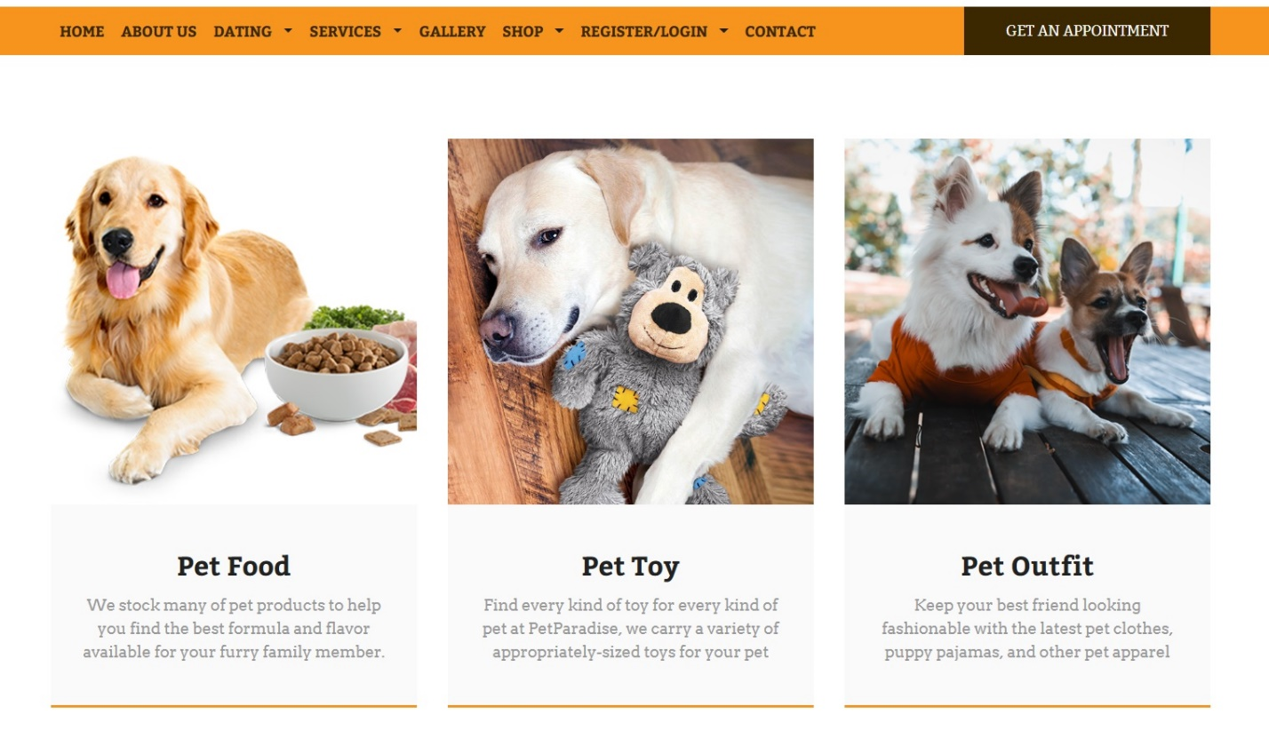

|  |  |
| --- | --- |
| Description | All galleries will show up |
| Connect From | Home |
| Connect To | Shop |
| Validation | N/A |
| Initial Values | N/A |
| Events | - When click Gallery’s name or Gallery’s photo 🡪 products of that gallery will show up |

* + 1. ***Product***

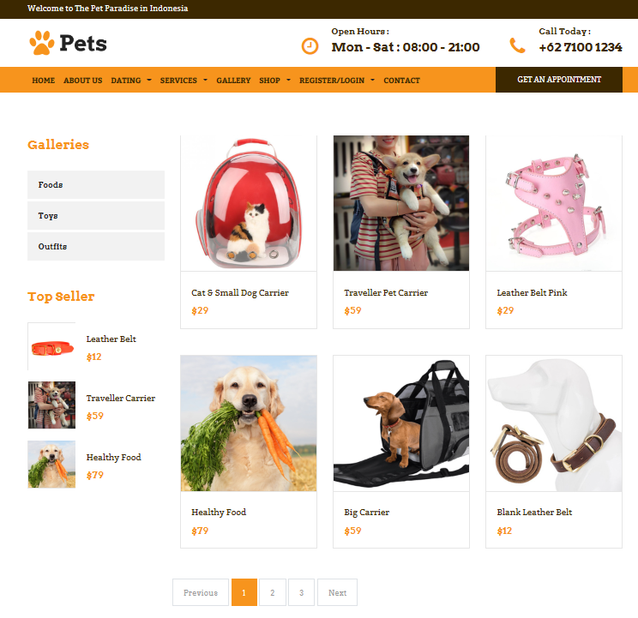

|  |  |
| --- | --- |
| Description | Show list of products, galleries and top sellers |
| Connect From | Home, category |
| Connect To | Product detail, cart |
| Validation | N/A |
| Initial Values | List of products following given criteria (category, images, price, description) |
| Events | - When click on product, redirect to product detail |

* + 1. ***Product details***

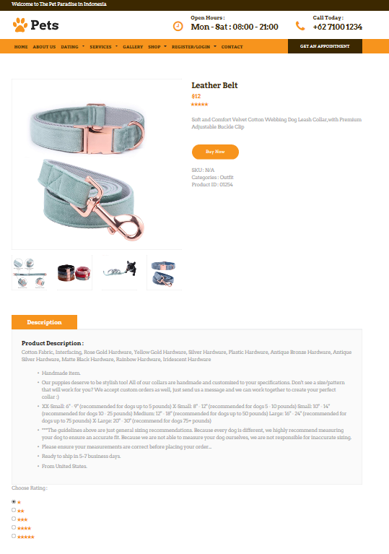***­***

|  |  |
| --- | --- |
| Description | Show product’s detail |
| Connect From | Home, product page, cart |
| Connect To | Cart |
| Validation | N/A |
| Initial Values | Product’s detail: name, price, images, description |
| Events | - When click button “Buy now”🡪 product’s added to cart |

* + 1. ***Popular product (top seller)***

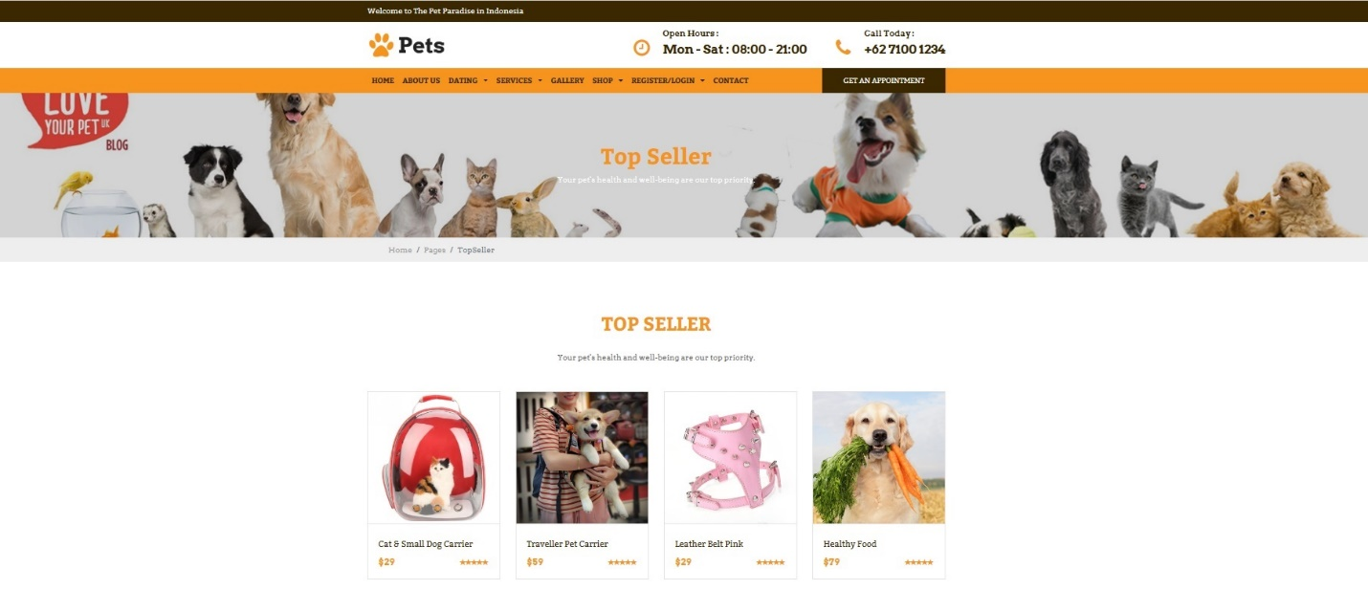

|  |  |
| --- | --- |
| Description | Show popular products (top seller) |
| Connect From | Shop page |
| Connect To | Product’s detail |
| Validation | N/a |
| Initial Values | N/A |
| Events | - When click on product, redirect to product detail |

* + 1. ***Search and filter product***

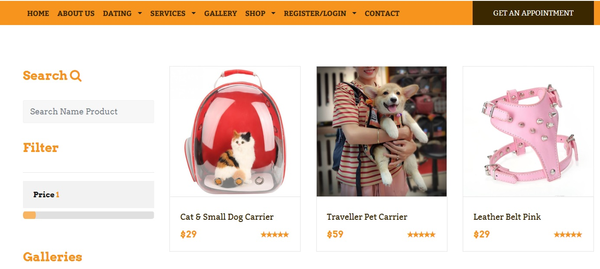

* + 1. ***About us***

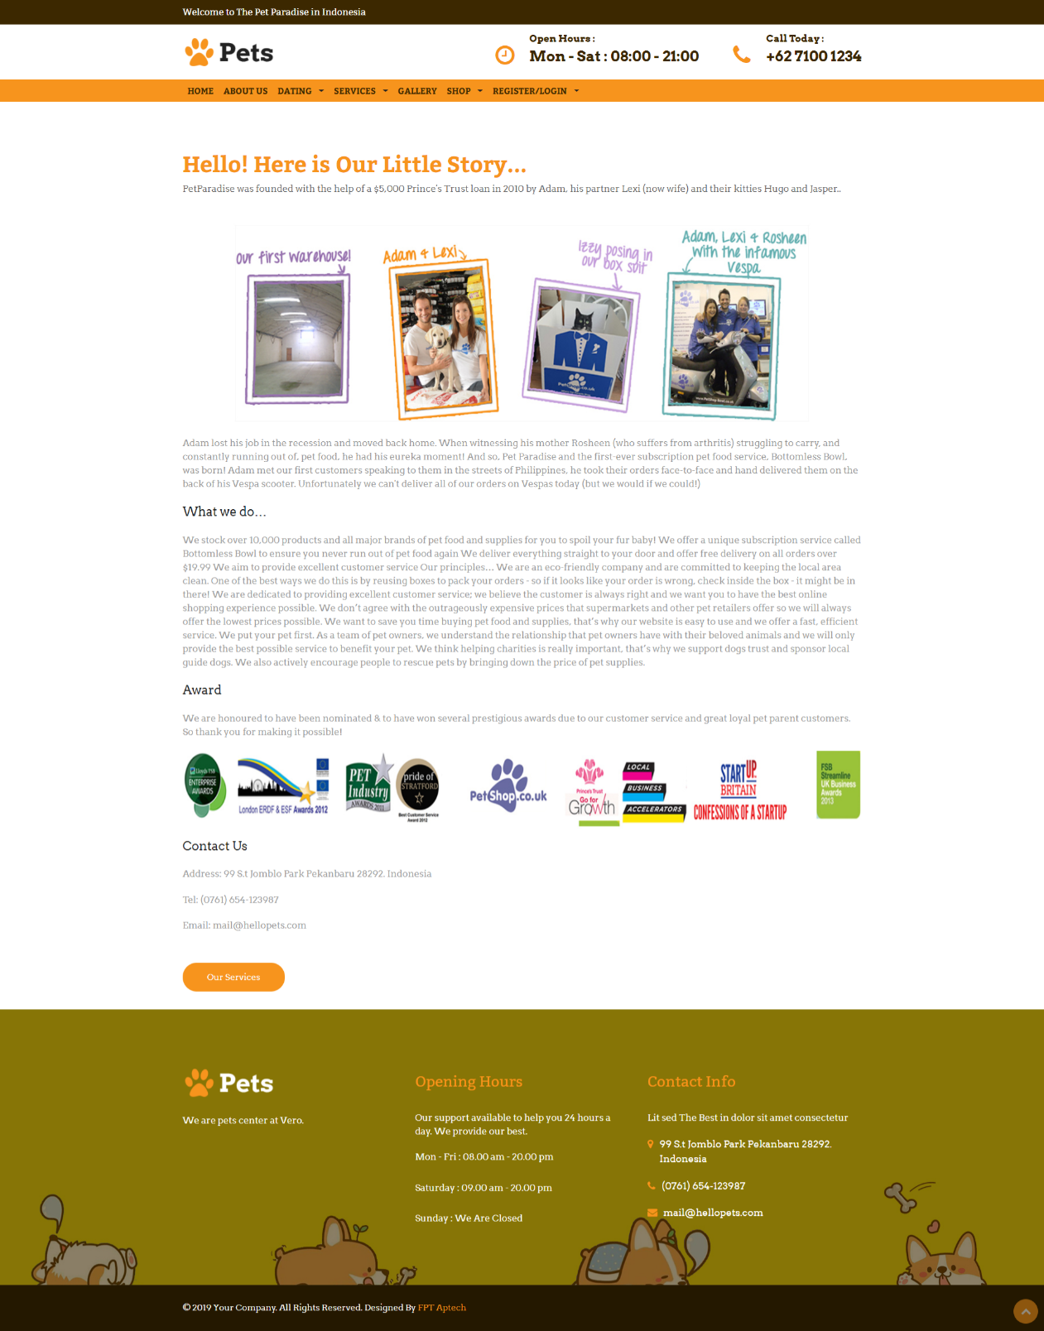

|  |  |
| --- | --- |
| Description | About-Us page |
| Connect From | N/A |
| Connect To | N/A |
| Validation | N/A |
| Initial Values | N/A |
| Events | N/A |

* + 1. ***Cart page***

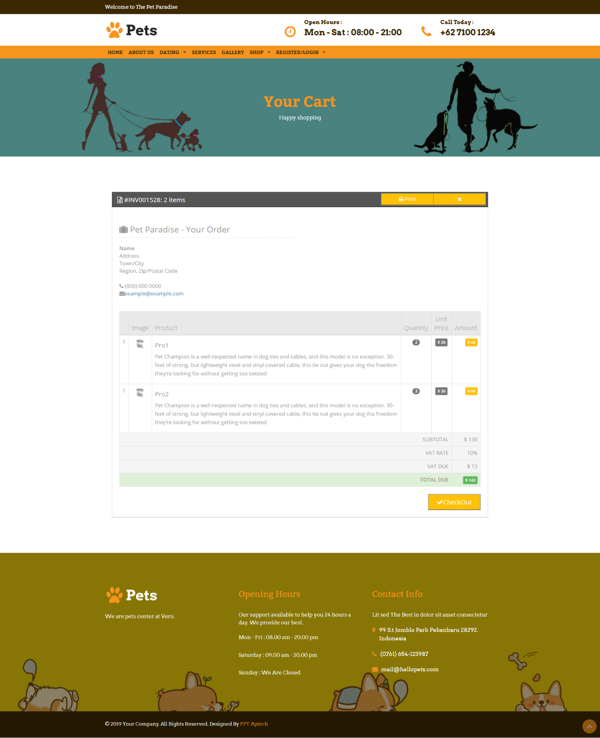

* + 1. ***Appointment form***

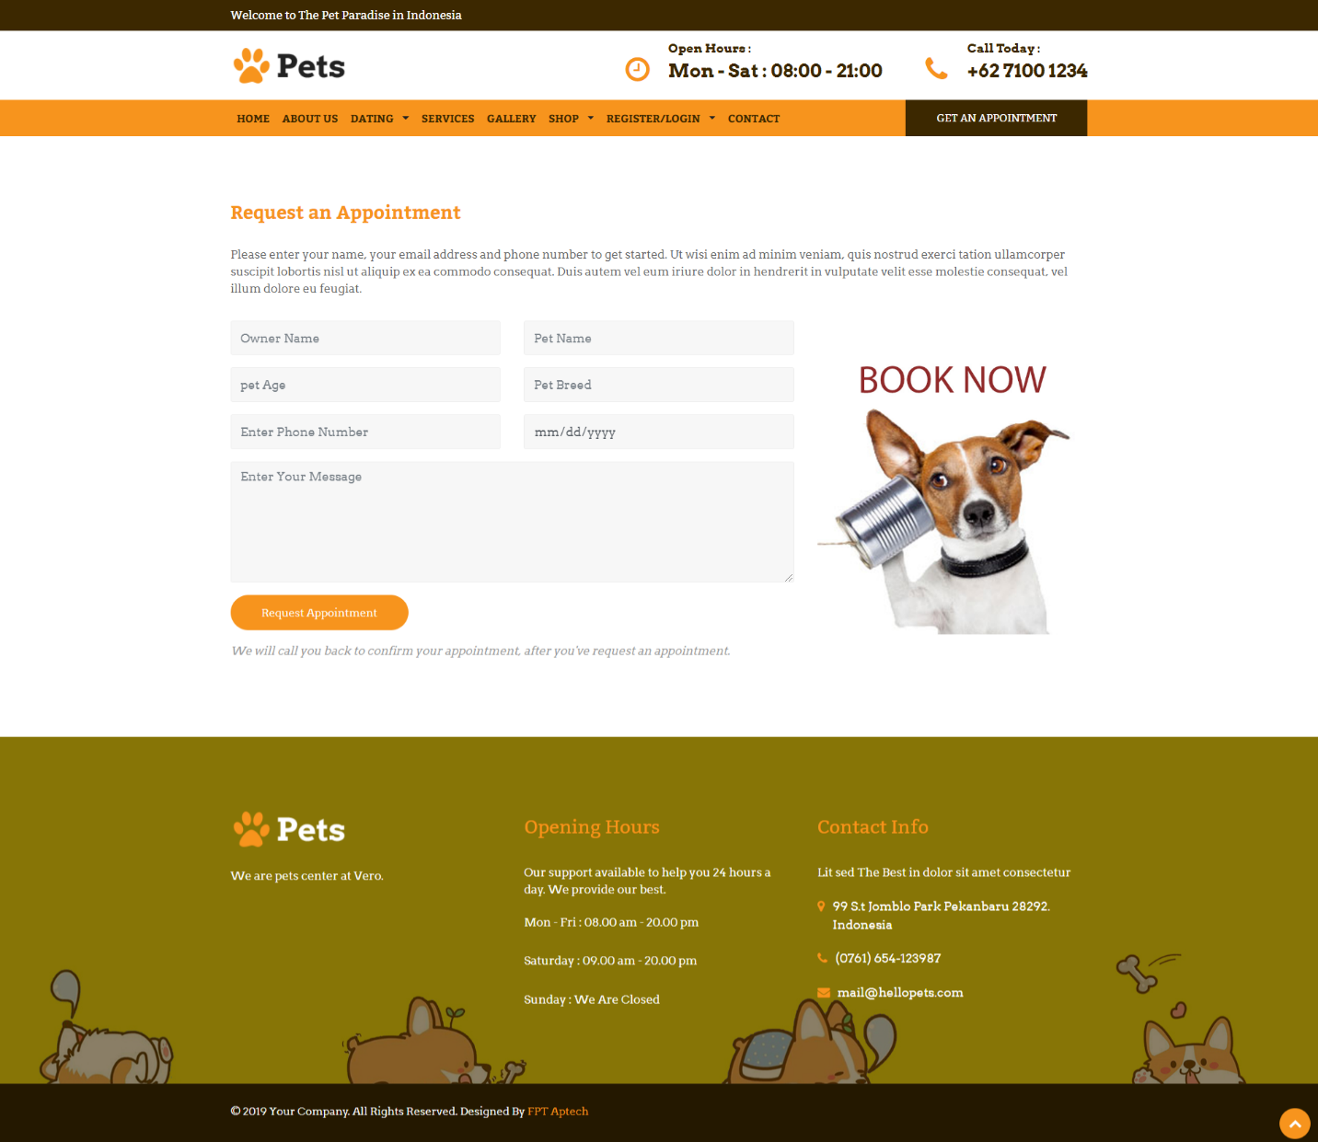

* + 1. ***Service***

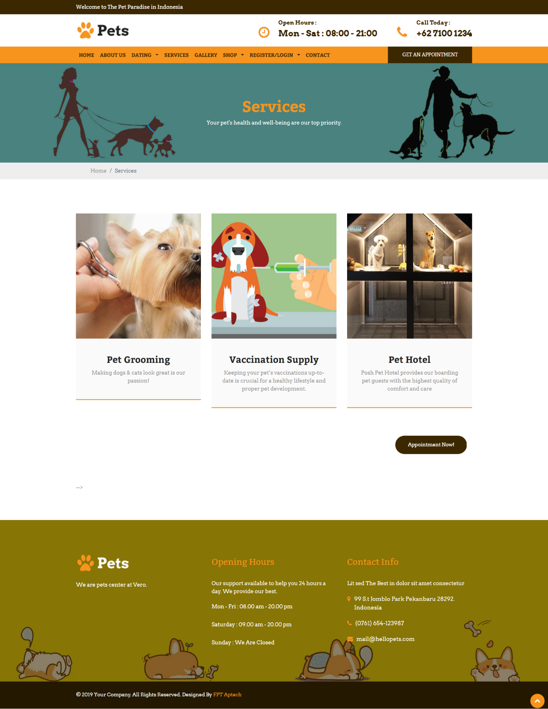

* + 1. ***Service Detail***

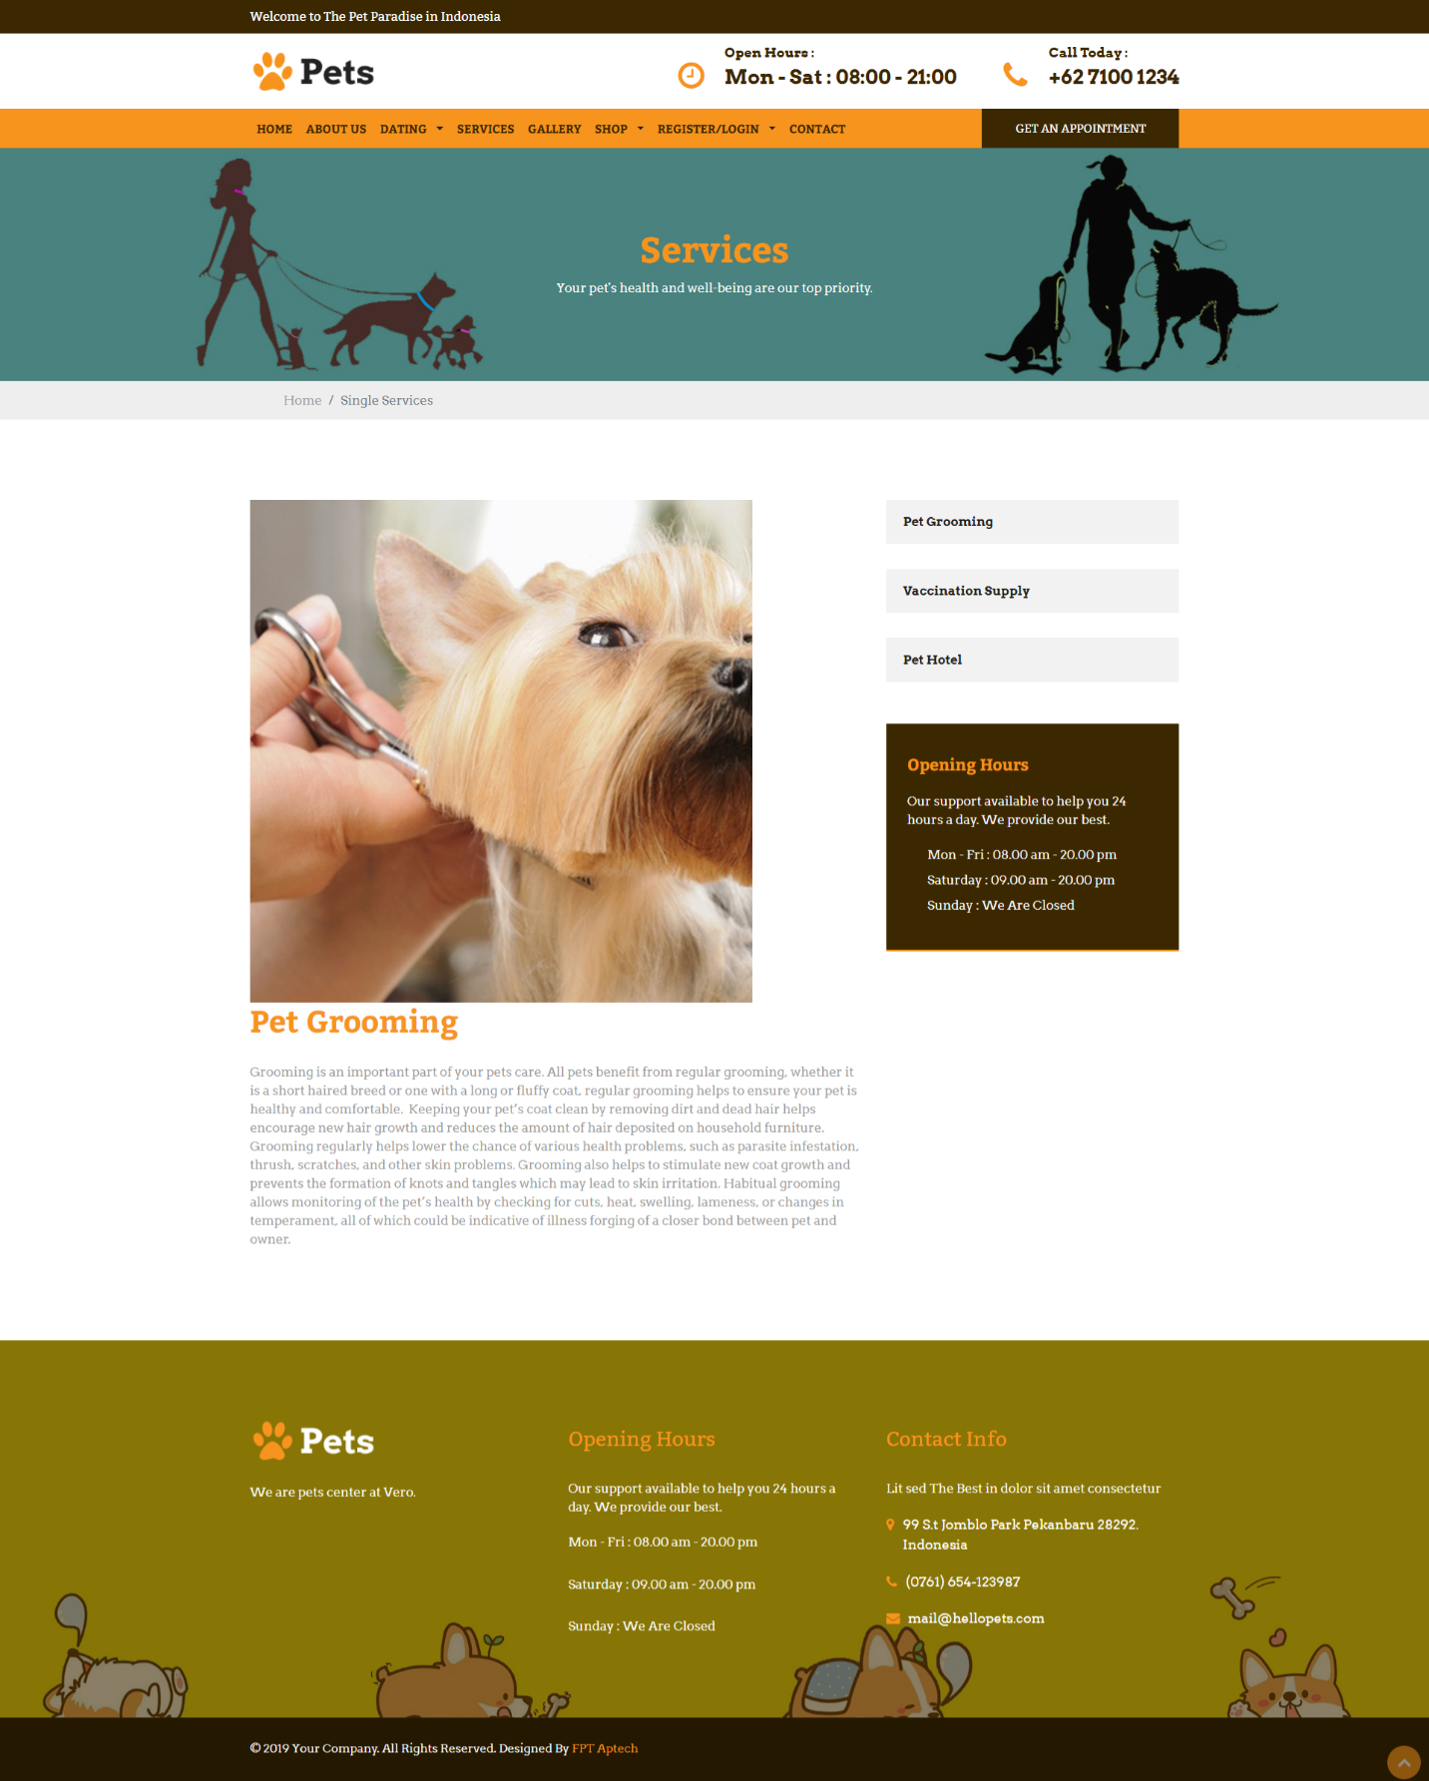

* + 1. ***sada***

1. **Admin’s Site**
   * 1. ***Admin Login***

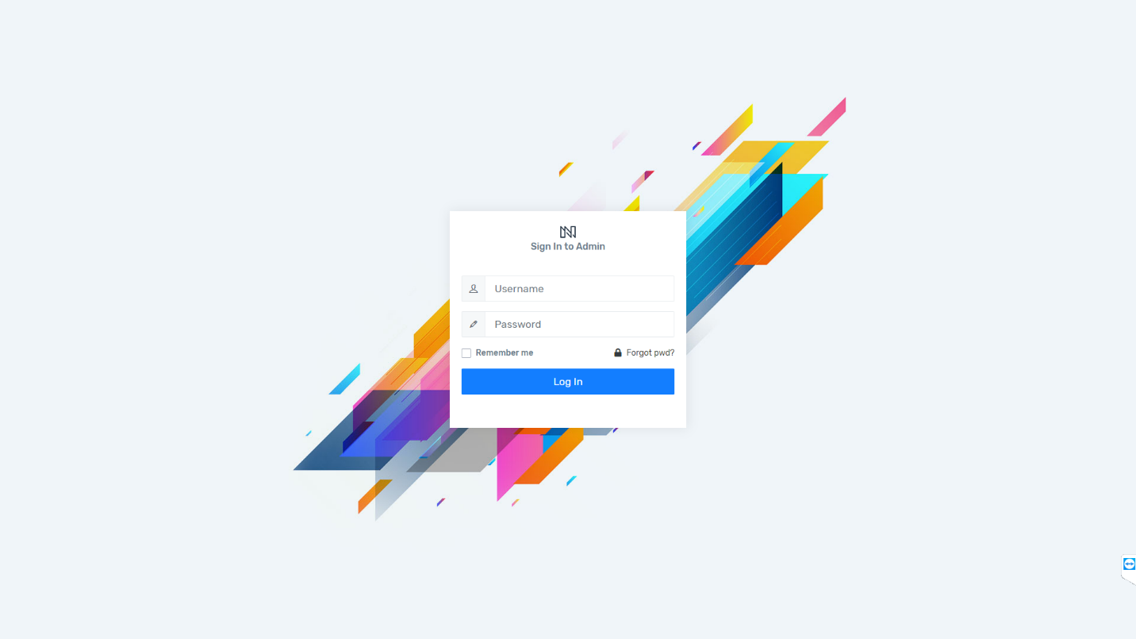

* + 1. ***Admin’s Dashboard***
    2. ***Category list***

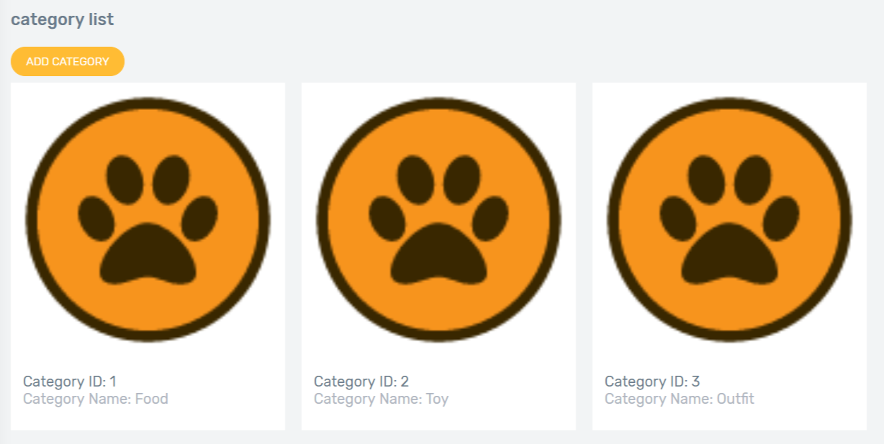

* + 1. ***Category add***
    2. ***Category update***
    3. ***Category delete***
    4. ***Product list***
    5. ***Product details***
    6. ***Product add***
    7. ***Product update***
    8. ***Product delete***
    9. ***Service List***

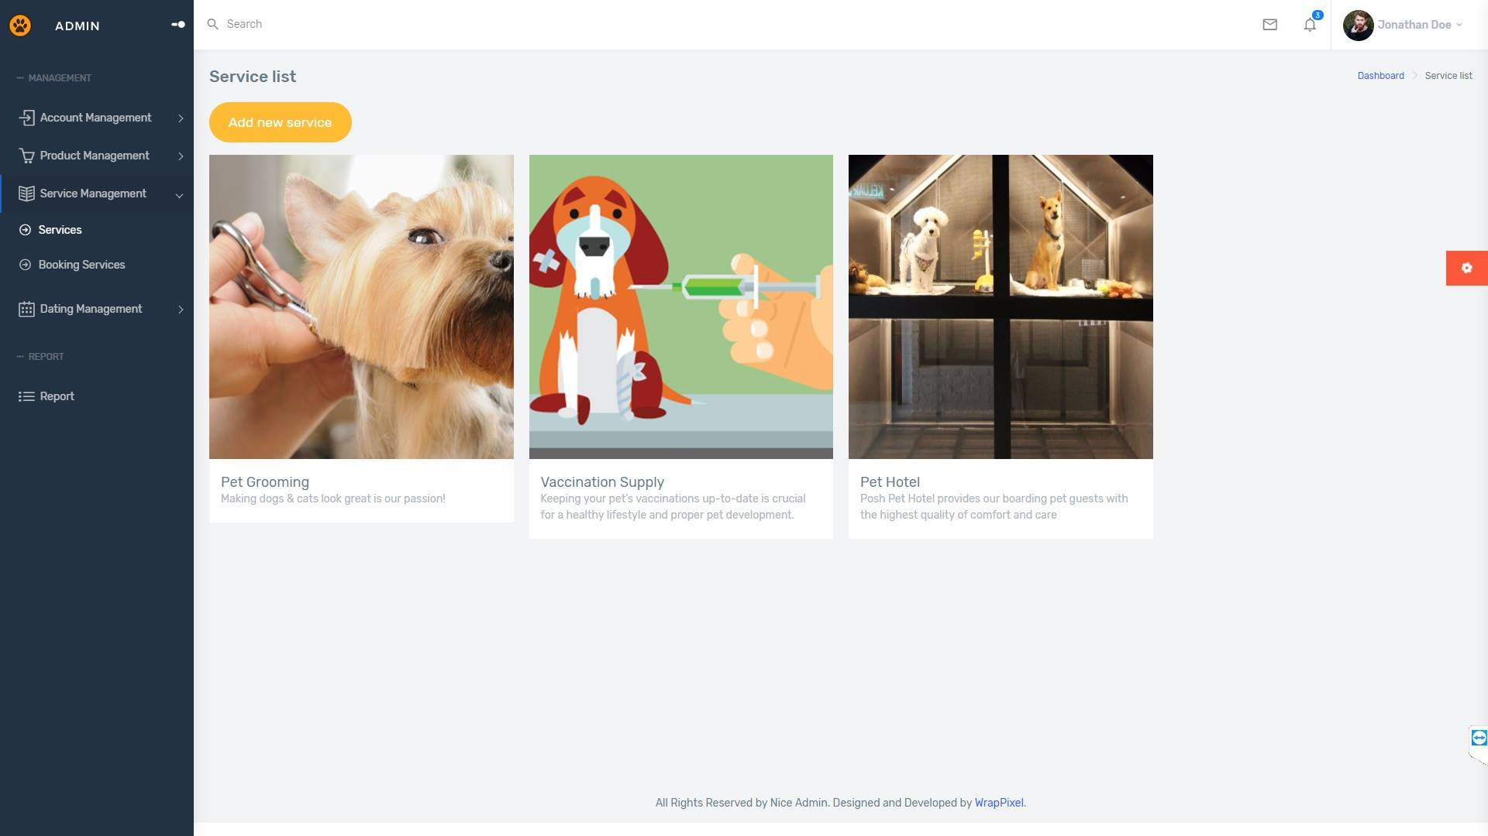

|  |  |
| --- | --- |
| Description | List all services |
| Connect From | Sidebar’s Service Manage tab |
| Connect To | Service Detail  Create new Service  Service Edit |
| Validation | N/A |
| Initial Values | Service List |
| Events | - Click on button "Add new service": Go to Add new service page.  -Click on icon “Detail”: Go to Service detail page  -Click on icon “Edit”: Go to Service edit page |

* + 1. ***Service Add***

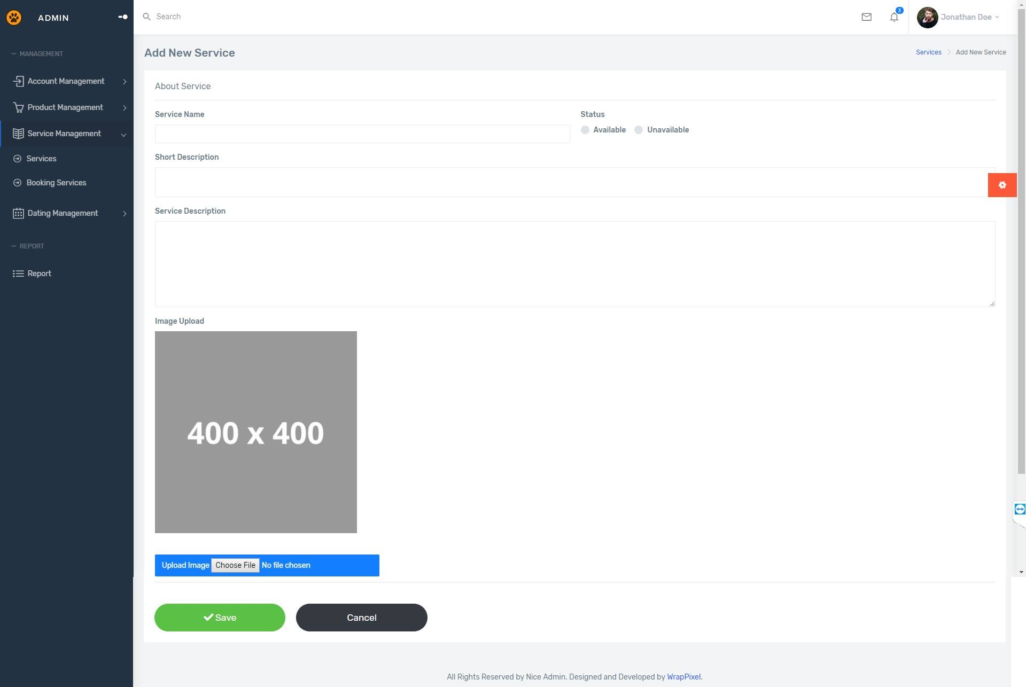

|  |  |
| --- | --- |
| Description | Add a new service |
| Connect From | Service List page |
| Connect To | N/A |
| Validation | -All fields: not blank - Name: must be unique |
| Initial Values | N/A |
| Events | - Click on button "Save": check all field validation. Add a new service to database.  -Click on button “Cancel”: reset all field. |

* + 1. ***Service Update***

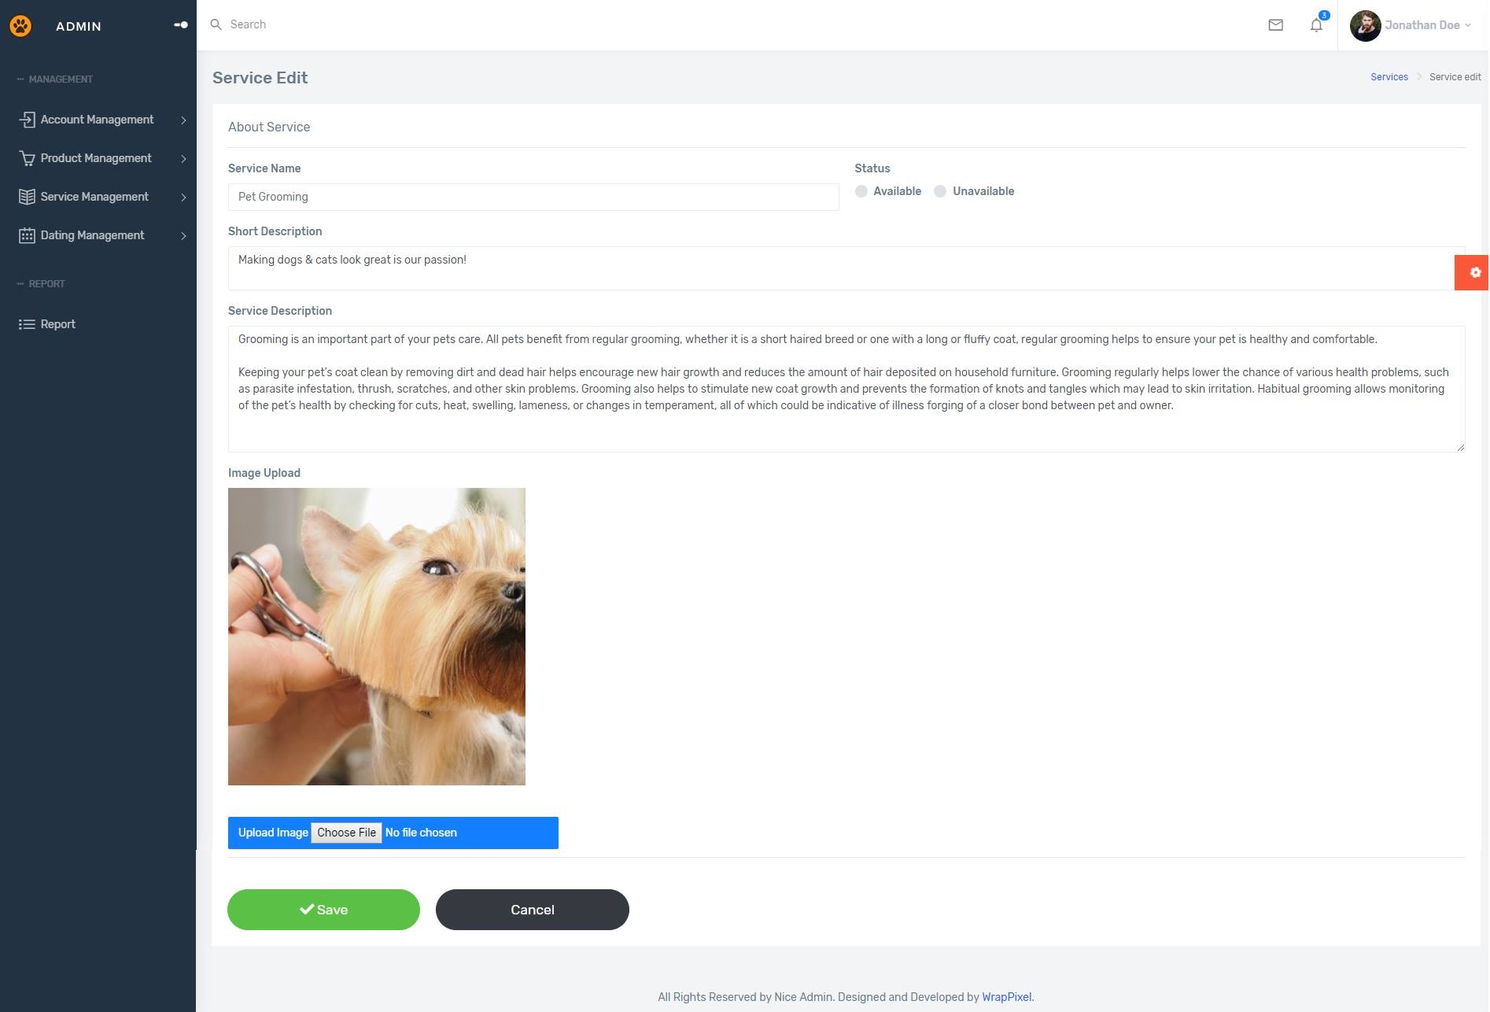

|  |  |
| --- | --- |
| Description | Update Service |
| Connect From | Service List; Service Detail |
| Connect To | N/A |
| Validation | All fields: not blank - Name: must be unique |
| Initial Values | Product Detail |
| Events | - Click on button "Save": check all field validation. Update detail to database.  -Click on button “Cancel”: redirect to Service detail page. |

* + 1. ***Service Delete***

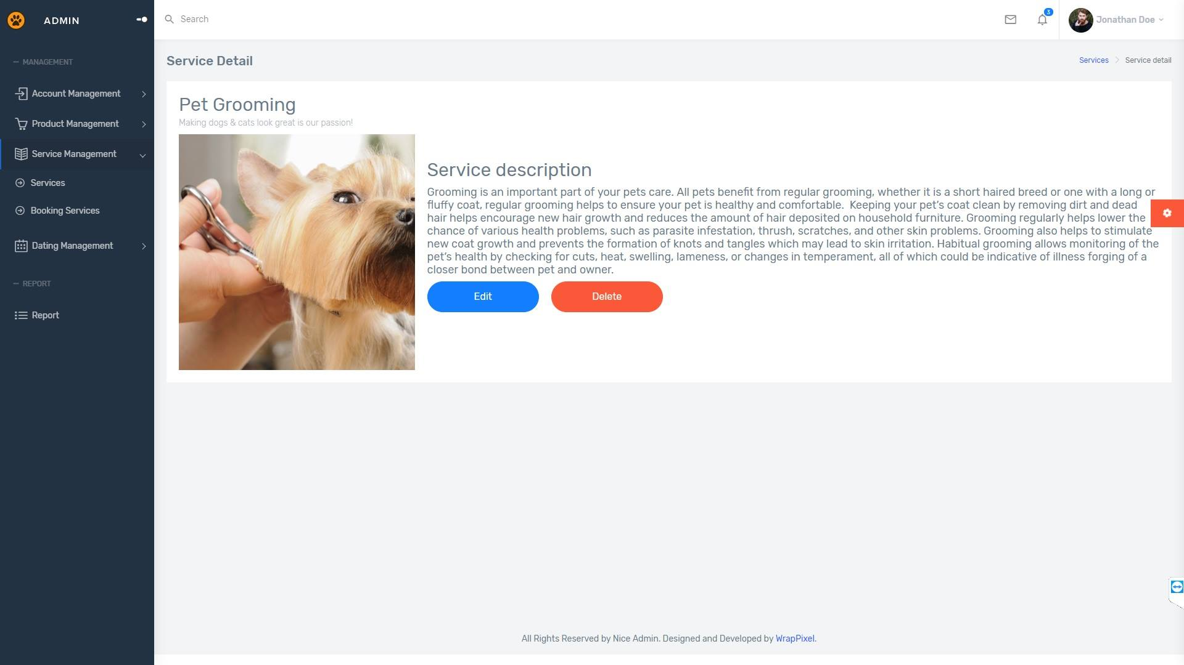

|  |  |
| --- | --- |
| Description | Delete Service |
| Connect From | Service Detail |
| Connect To | N/A |
| Validation | N/A |
| Initial Values | Product Detail |
| Events | - Click on button "Delete": confirm again. Delete service from database. |

REVIEW 3 – TASK SHEET

|  |  |  |  |  |  |
| --- | --- | --- | --- | --- | --- |
| **No.** | **Contents** | **Member** | **Activity Plan** | **Preparation** | |
| **Start Date** | **Actual Days** | **Status** |
| **Client** | | Tran Tan Duy | 10/04/2019 | 15 | Completed |
| 1 | Homepage |
| 2 | Product: new, hot |
| 3 | Product: view by Category |
| 4 | Product’s detail |
| 5 | Orders |
| **Admin** | |
| 6 | Category: view, add, update, delete |
| 7 | Product: view, add, update |
| 8 | Order: view, update status |
|  | | | | | |
| **Client** | | Le Cong Dat | 10/04/2019 | 15 | Completed |
| 1 | GUI Design |
| 2 | Login/Logout |
| 3 | Customer register |
| 4 | Customer’s profile: update |
| 5 | Cart: add, update, remove |
| 6 | Calculate shipping fee with Google API |
| **Admin** | |
| 7 | GUI Design |
| 8 | Login/Logout |
| 9 | Admin permission |
| 10 | AdminAccount: view, add, update |
| 11 | Customer: view, ban (update) |
| 12 | CustomerAddress: view |
|  | | | | | |
| **Client** | | Tran Thi Tuyet Duyen | 10/04/2019 | 15 | Completed |
| 1 | Wish List: view, add, delete |
| 3 | Search products by relative name |
| 4 | Filter products by: category, price |
| 5 | Sort by: top seller |
| 6 | Caterogy: view |
| **Admin** | |
| 8 | Review: view, response (update), delete |
| 9 | Caterogy: view, add, update, delete |

Plan prepared by: Group 2 April 29th, 2019  
 **Group Leader Faculty**

**Tran Thi Tuyet Duyen Mr. Cat Nghiem Hieu Tuan**